**Cross-Site Scripting**

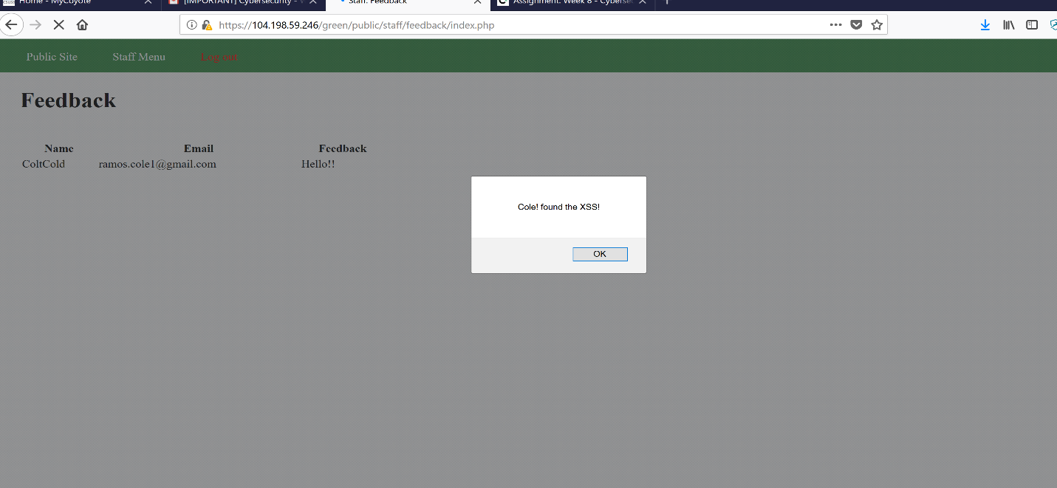

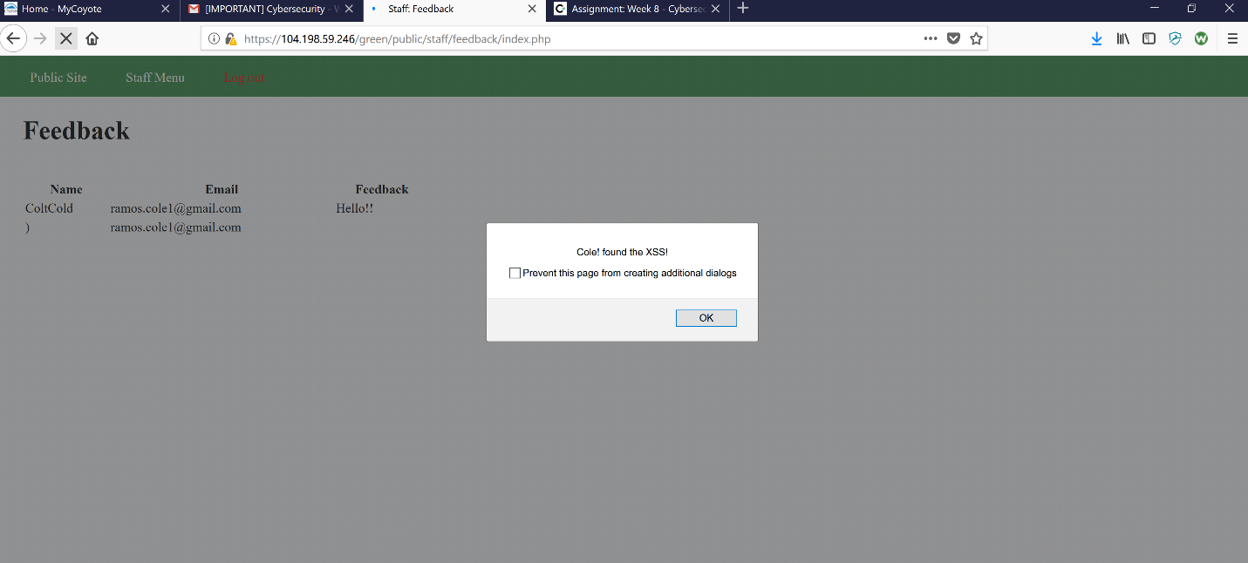

* The site’s feedback is open XSS alert vulnerability.
* To find this vulnerability in feedback form by filling out the information and inserting <script>alert('Mallory found the XSS!');</script>) into the email part of feedback for.